The Why and How: Converting Incandescent and Halogen Light Bulbs to LEDs
Why convert?:
- Savings: Annually, you save $5.00/bulb in electricity costs powering a 9W LED vs a 60 W conventional bulb for two hours a day. Multiply that by your number of bulbs….
- Pay-back: Don’t wait for old bulbs to fail; replace them now! Because LED prices have fallen, the pay-back time on a 60W bulb used two hours/day is about 6 months. If used four hours/day, the pay-back time is 3 months.
- Efficiency: LED bulbs are 6-8 times more efficient. (Releasing 80+% of energy as light and not heat.)
- Durability: LEDs are much less fragile and last 15-30 times longer than incandescent bulbs. Never change another bulb?!
- Excellent light: When selected correctly, LED bulbs often provide superior lighting.
- Rebates: SMPA rebates often cut your replacement costs by 50%, cutting your pay-back time in half. See:
http://www.smpa.com/content/rebate-programs To claim your rebate, an application form must be completed and sent or delivered to SMPA (see link to print the rebate application form) along with one or more recent (less than 180 days old) LED purchase receipts. There is an annual member cap on these rebates (see the application form), generally 50 LED bulbs or $150 for the most common LED options.
- Easy assistance: For the last several years, SMPA, EcoAction Partners, and our local communities have teamed to give up to 75% rebates on LED light purchases through selected local vendors. A major benefit of this program is that a professional can help you with LED lamp selection and replacement with no decrement in your overall savings. www.ecoactionpartners.org/greenlights The next special rebate period is in May 2018. (If you already know the optimal replacement bulbs for your fixtures, find them at a good price, and are able to replace them yourself, there is little reason to wait. In the end, savings are generally comparable.)
How does one select comparable replacement bulbs? Replacement bulbs should be chosen based on their brightness (lumens) and the type (temperature) of light desired (soft white vs. a brighter white), not based on watts consumed. If the replacement fixture uses a dimmable bulb, the selected LED should indicate the ability to be used in a dimmable fixture (to prevent flicker/hum at certain levels). [For pros & cons of CFL replacement, see that section below]
Watts vs. lumens: The following table allows one to see what lumen level is associated with the wattage of a conventional incandescent bulb. Chose a replacement bulb generating comparable lumens for the same amount of light.
Incandescent/Halogen Wattage Lumens LED or CFL Wattage
40 450 9-13
60 800 13-15
75 1100 18-25
100 1600 23-30
125 2000 22-40
150 2600 40-45
Light temperature: The temperature of light is measured in Kelvins (K). Traditional incandescent bulbs put out a softer, yellowish light in the 2400-2700 K range. Light in this 2500-3000K range is generally used (less glare) for most home uses. LEDs are capable of putting out a much larger range of light temperatures so one should be careful to consider the K designator as well as the lumens. Perhaps the major source of dissatisfaction with home LED use is caused by choosing a whiter/more blue light where a softer light has been used before and would be more pleasing. Outside lights should also be a warmer shade (<3000K). There are, however, some good uses for this higher K, whiter light – schools, libraries, garages, workspaces… - and such light can help promote alertness. If in doubt, go with a warmer white (lower K) and not a daylight white. 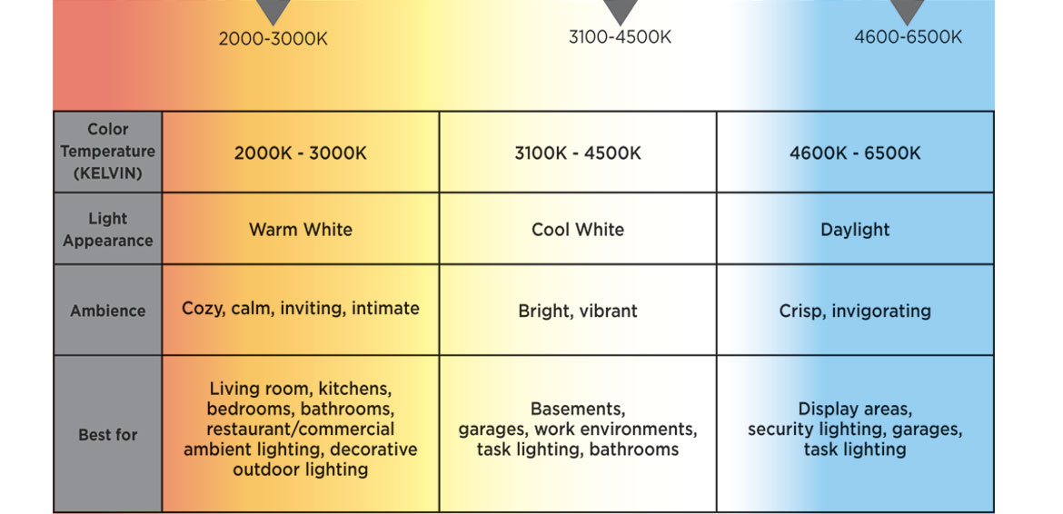
http://www.westinghouselighting.com/color-temperature.aspx
Local SMPA LED rebates: In 2018, SMPA provides LED rebates as follows:
Rebate | Amount
LED Lamps & Fixtures | 50% of bulb cost up to $8/bulb; max 50 bulbs; 500 Lumen min.
LED Yard Lights | 50% of fixture cost up to $100; max 3 fixtures
LED Tube Light | 50% of bulb cost up to $8/ft; max $360
LED Strip, Short Tube & Bar Light | 50% of bulb up to $8/ft.; max $150
LED Small Bulb & Pin Light | 50% of bulb cost up to $4/bulb; max $150
http://www.smpa.com/content/rebate-programs
What do I do with the traditional bulbs once they are removed? Traditional bulbs (not CFLs, see below) can be put in the trash. While one can also give them away, their energy efficiency makes them a poor choice for all users. Giving someone a traditional bulb for free isn’t a nice present; the energy that bulb uses would have quickly paid for a more efficient LED. If in doubt, SMPA is happy to accept traditional light bulbs at their office and will properly dispose of them. For CFL disposal, read on….
What about Compact Florescent Lights (CFLs)? Larger bulb (above 60W) CFLs use about the same amount of energy as LEDs (but CFLs use 2-3 times more energy as LEDs in the 40-60W sizes). CFLs are more fragile but, when protected, can last 10 years. LEDs are less fragile and usually last 15-20 years. CFLs are often slow to start, taking several minutes to reach full brightness, a problem that LEDs don’t have. CFLs also put out more heat. The biggest problem with CFLs is that they contain significant mercury and are ideally disposed of as toxic waste, not placed in the garbage. While one should not ever buy another CFL given their mercury content and the many advantages of LEDs, one may choose to use current CFLs until they burn out. If one decides to replace them early (or after the CFL burns out), one can bring the bulbs to the SMPA office, and they will assure proper disposal.
The future: According to Energy Star, if each household changed just 1 bulb, the reduction in greenhouse gas emissions would be the equivalent of taking 2 million cars off the road. Energy.gov notes that by 2027 widespread use of LEDs could save about 348 TWh of electricity, the equivalent of the annual electrical output of 44 electric power plants (1000 megawatts each) - also a total savings of more than $30 billion at today’s electricity prices. (As of 2018, California no longer sells traditional light bulbs. A 2007 bipartisan bill signed by President Bush aimed to phase out incandescent lightbulbs in the U.S. beginning in 2012. Congress has slowed this transition by choosing not to fund enforcement, but, like the economics of renewable energy, the falling prices and many advantages of LEDs continue to drive this transition.)

Local LED light bulb options: As a point of reference, this section gives a few comparison bulbs and 1/2018 prices. These are not recommended sources or bulbs, only examples for comparison purposes. LEDs can also be easily purchased over the internet.
Remember: In addition to the wattage equivalent and the type of bulb, it is key to pay attention to the temperature (warmth) of the light (in Kelvins/K) and, based on the desired use, whether the bulb is dimmable. Soft white or warm white (2700K) bulb temperatures are often preferred for the most common home uses. All LED bulbs have a long life but some are rated longer than others and some have a guaranteed life. While this list includes largely traditional light bulbs and flood lights, LEDs come in a myriad of shapes and sizes and can be found to fit almost any fixture. Based in part on volumes and significant competition, prices have become very competitive.
Home Depot LED bulbs:
EcoSmart 60W Equivalent Daylight Classic Glass A19 Energy Star and Dimmable Filament LED Light Bulb
(4-Pack) 5000K 840 lumens 7.5W 15000 hours $9.88
EcoSmart 60W Equivalent Soft White A19 Basic Non-Dimmable LED Light Bulb (8-Pack), 2700K, 11000
hours 800 lumens 9W $11.38
EcoSmart 60W Equivalent Soft White A19 Dimmable CEC LED Light Bulb (4-Pack), 2700K, 800 lumens, 11W, 22.8 yrs, $9.48
Cree 60W Equivalent Soft White (2700K) A19 Dimmable LED Light Bulb (4-Pack), 25000 hours, 815
lumens, 9.5W $19.97
Cree 65W Equivalent Soft White (2700K) BR30 (flood) Dimmable LED Light Bulb (3-Pack), 665 lumens,
2700K, 22.8 yrs, 9.5W, $24.97
Feit Electric 65W Equivalent Soft White BR30 (flood) Dimmable LED Light Bulb Maintenance Pack (12-
Pack), 650 lumens, 2700K, 9.5W, 10 yrs, $37.54
Philips 75W Equivalent Frosted A21 Dimmable WarmGlow LED Light Bulb, 1100 lumens, 2100-2700K,
12W, 22+ yrs, $9.97
CREE 75W Equivalent Soft White A19 Dimmable LED Light Bulb, 1100 lumens, 2700K, 13.5W, 22.8 yrs,
$10.97
EcoSmart 75W Equivalent Soft White BR40 (flood) Dimmable LED Light Bulb (3-Pack), 940 lumens,
2700K, 13.5W, 22.8 yrs (based on 3 hrs/d), $25.97
Cree 85W Equivalent Soft White (2700K) BR40 Dimmable LED Flood Light, 1120 lumens, 12.5W, 22+ yrs,
$14.97
EcoSmart 85W Equivalent Bright White PAR38 (flood) Dimmable LED Light Bulb (2-Pack), 850 lumens,
3000K, 13W, 22.8 yrs, $14.88
EcoSmart 85W Equivalent Soft White BR40 (flood) Dimmable LED Light Bulb (2-Pack), 1110 lumens,
2700K, 16W, 22+ yrs, $11.99
Philips 100W Equivalent Soft White A19 Non-Dimmable LED Light Bulb (2-Pack), 1500 lumens, 2700K,
14.5W, 10 yrs, $12.97
EcoSmart 100W Equivalent Soft White A19 Basic Non-Dimmable LED Light Bulb (4-Pack), 1500 lumens,
2700K, 14.5W, 9.1 yrs, $15.12
EcoSmart 100W Equivalent Soft White A19 Dimmable LED Light Bulb (2-Pack), 1600 lumens, 2700K,
15W, 22.8 yrs, $10.27
Cree 100W Equivalent Soft White (2700K) BR30 (flood) Dimmable LED Light Bulb, 1500 lumens, 16.5W,
22.8 yrs, $10.97

Walmart LED bulbs:
Newhouse Lighting Halogen Replacement 3W LED Bulb, 25W Equivalent, 12 volts, G8 Base, 280 lumens,
2700-3000K, 35,000 hrs, $8
Great Value LED Decorative Candelabra Base Light Bulb, 3W (15W Equivalent), Soft White, Non-
dimmable, 120 lumens, 2700K, $3.67
Great Value LED Globe Light Bulb, 5W (40W Equivalent), Soft White, Non-dimmable, 350 lumens, 22 yrs,
1-count, $5.77
Great Value LED Light Bulbs, 8.5W (60W Equivalent), Soft White, Non-dimmable, 4-count, 800 lumens, 9
yrs, $5.54
TorchStar A19 LED Light Bulb, 9.5W (60W Equivalent), 2700K Soft White, Non-dimmable, 2 yr warranty,
Pack of 6, $11.99
Maxxima LED A19 - 800 Lumens 60 Watt Equivalent Warm White (2700K) Light Bulb, 10 W (Pack of 12),
25,000 hrs, $23.97
Sylvania LED Light Bulbs, 12W (75W Equivalent), Soft White, Non-dimmable, 4-count, 1100 lumens,
11,000 hrs, $14.74
Simply Conserve LED 11W BR30 Dimmable Flood Light Bulb, 2700K, 60W Equivalent, 850 lumens, 23 yrs,
$12.83
Philips LED Dimmable Flood Light Bulb, BR40 (flood), Soft White with Warm Glow, 65 W Equivalent, 9W,
2200-2700K, 22+ years, $10.04
Philips LED Light Bulb, A19, Soft White, 100 Watt Equivalent, non-dimmable, 14.5 W, 1500 lumens,
$8.50
Triangle LED Bulbs (Pack Of 4) 15-Watt (120-Watt) PAR38 LED Flood Light Bulb, Dimmable, 1050
lumens, 15W, 2700K, 22.8 yrs, $32.99
Lifespan: A typical incandescent bulb may last 1,000 to 2,000 hours before burning out. Compact fluorescent light bulbs have a lifespan approaching 10,000 hours, while LED bulbs could potentially last 25,000 to 50,000 hours or more before failing. When incandescent bulbs burn out, it happens suddenly due to a broken filament. In contrast, LEDs slowly fade away - they very very gradually dim. The industry standard for LED light bulbs is that, when operated for 3 hours per day, they should last for at least 25,000 hours with at least 70% as much brightness as they have when they are new. Below 70% is the point at which the industry decided the decrease in brightness is noticeable.

