ROCC Business Meeting
January 17, 2019
Ridgway High School Library, 7:00 p.m.

Announcements

Women’s March in Montrose on Saturday January 19. Meet at the SW corner of Townsend and Main St. at 9:30 am.

Approval of December 1, 2018 Business Meeting Minutes

Rein Van West made a motion to approve the minutes. Kathy Heffernan seconded the
motion. Motion passed.

Treasurer’s Report – Scott Williams

See report below.

Jim Stephenson made a motion to approve the report. Carolyn Ray seconded the motion.
Motion passed.
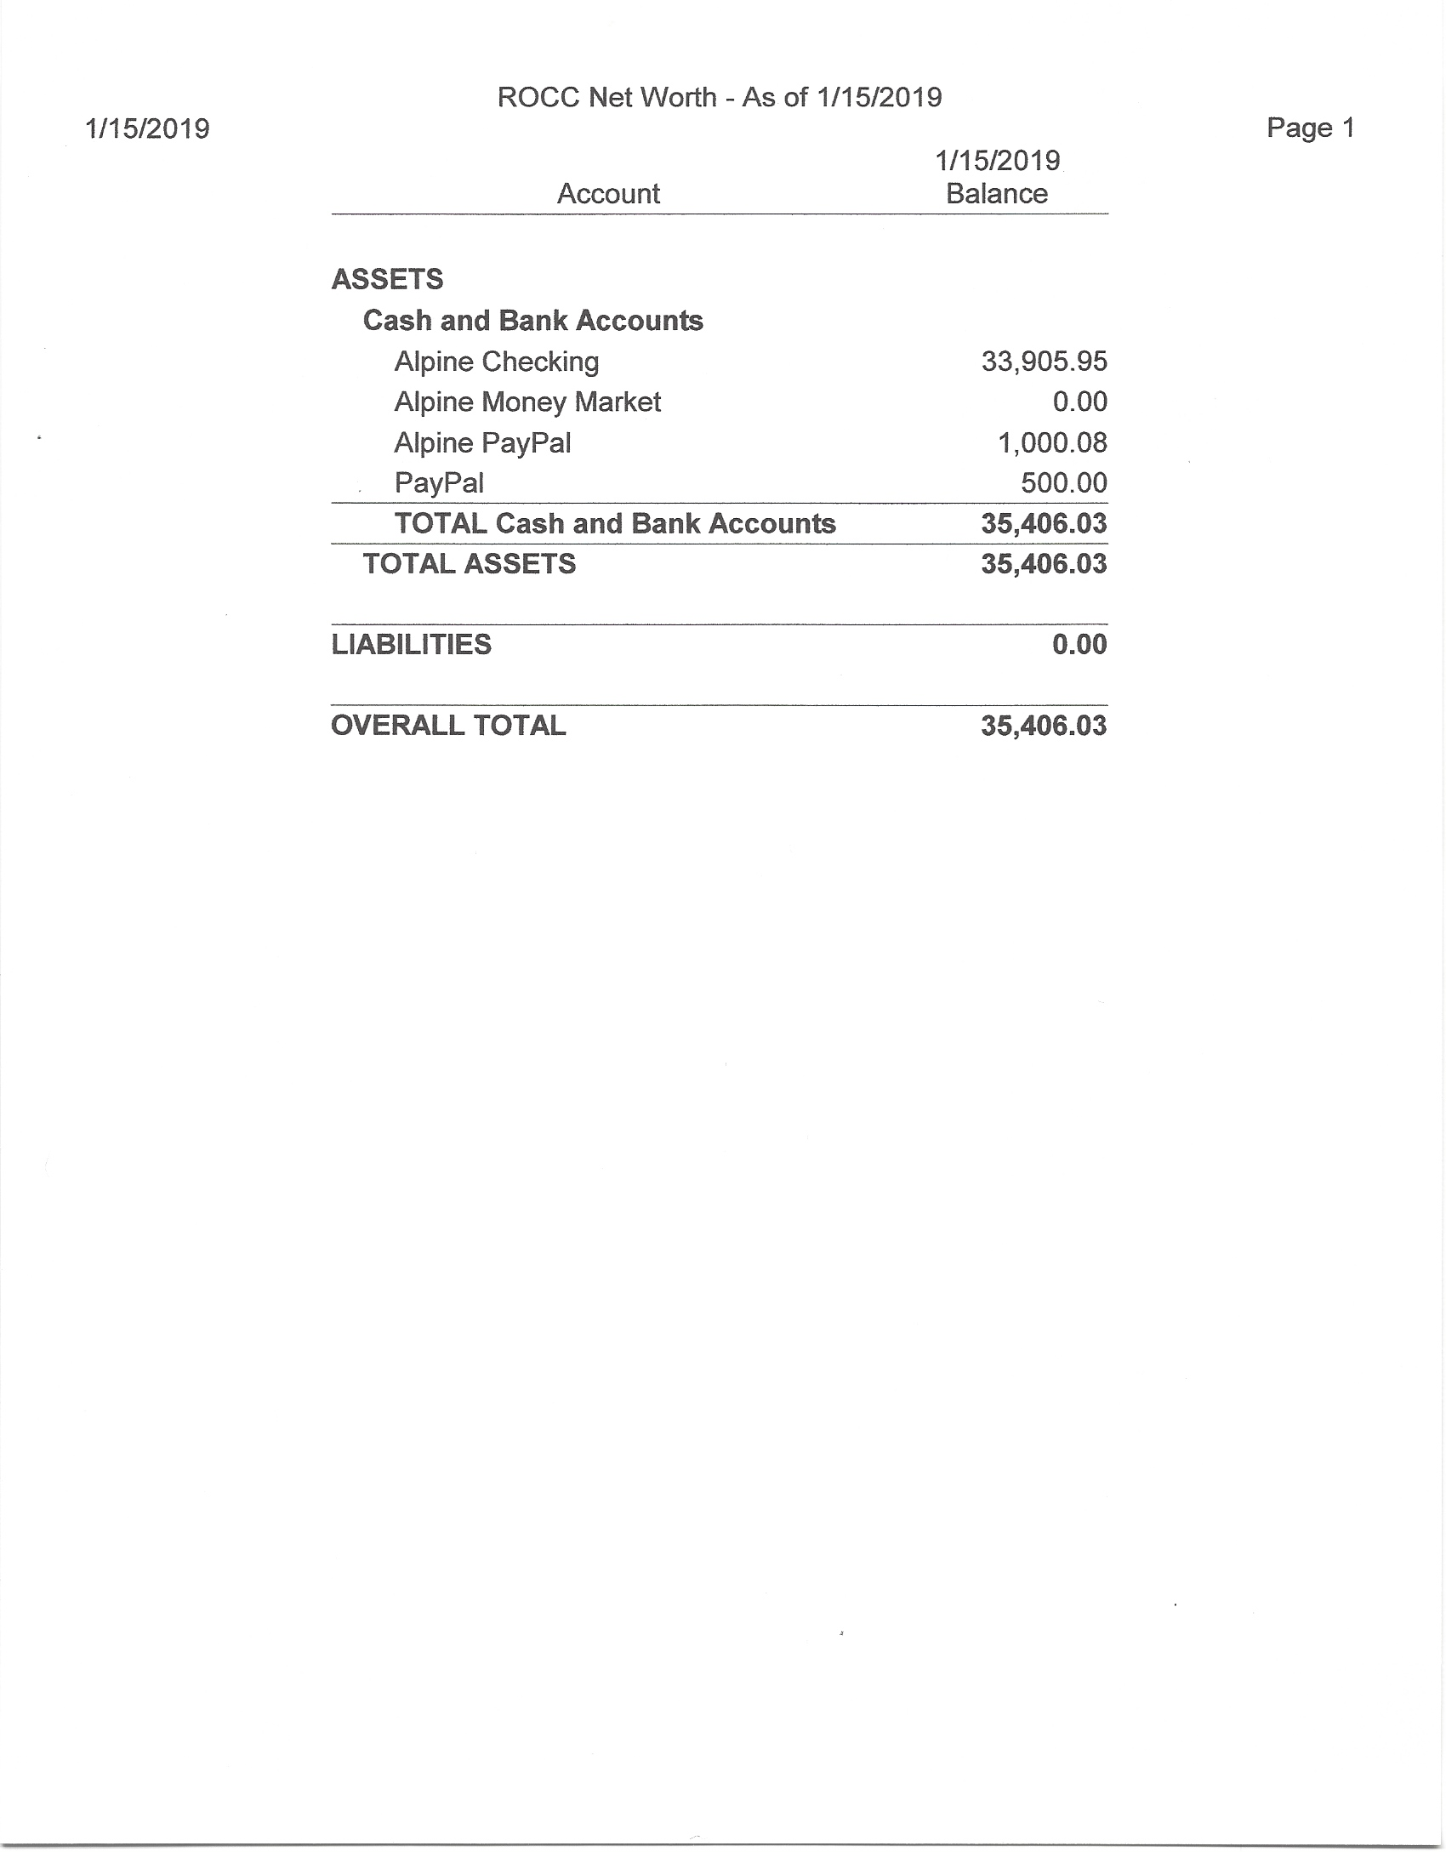

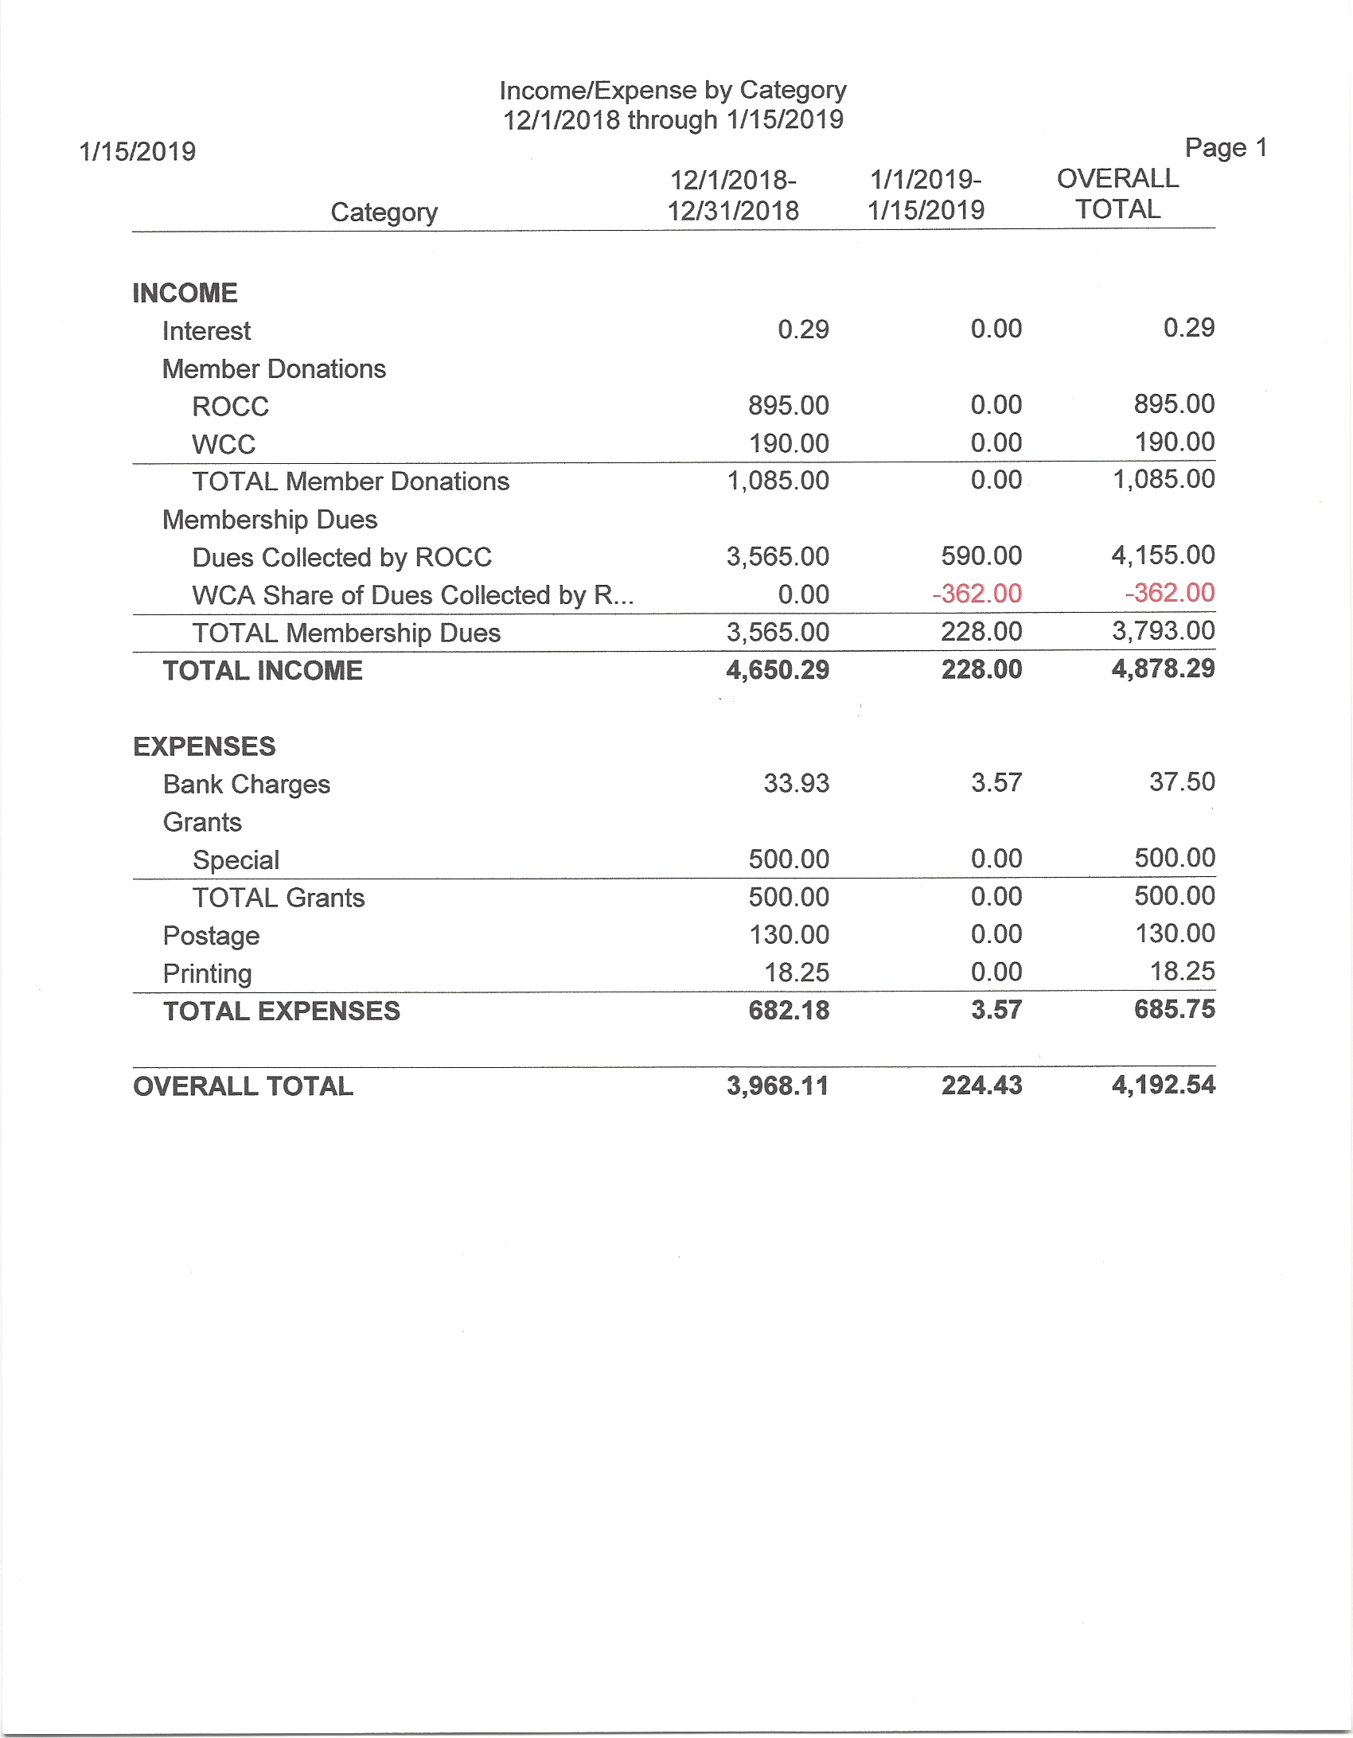

Old Business

Spaghetti Dinner

The dinner will be held on Thursday, February 21 and the guest speaker is Ellen Lapham.

Kate Kellogg got the liquor license this week.

Volunteers are needed to call people to bring sauces. Patsy Miller, Kate Kellogg and Al
Lowende volunteered to call people on the sauce list. And a number of people at the
meeting volunteered to make sauces.

Tom Heffernan is contacting the four girls and their parents about the ROCC Outstanding Citizens awards for their efforts to get the use of plastic bags ended in Ridgway.

Al Lowende also asked for volunteers to set up, clean up, serve and wash dishes for the
dinner.

John Hollrah will be running the kitchen again, and Scott Williams will be getting the
beer and wine.

Committee Reports

Social Justice – Kathy Heffernan

No report

Clean Energy – Rein Van West

Dave Jones made a presentation to the SMPA Board to add one cent per kilowatt-hour to customer’s bills for green energy blocks. This request may be approved at the March board meeting. The Green Fund is used for green energy projects.

Jack Sibold said at the CEC meeting this morning that Tri-State has contracted with a German Company to build a 100-megawatt solar farm north of Trinidad, Colorado.

Tri-State is considering changing its bylaws to allow more classes of co-op membership to give greater flexibility to its member co-ops for their individual needs. As just recently reported in the Montrose Press, Tri-State is suing DMEA over its attempt to leave the Tri-State cooperative.

Don Swartz mentioned that a good source for information on utilities is utilitydive.com.

Land Use – Dudley Case

See report below.
Al Lowande suggested that ROCC email Alan Todd at the Ouray Plaindealer and request
a clarification that ROCC and San Juan Huts Systems are using the same attorney, Paul
Kosnik, but that ROCC is not part of the San Juan Huts Systems potential lawsuit against
the county concerning CR 5.

Scott Williams expressed concern that the county isn’t being proactive about considering
winter recreation on other county roads, such as CR 7 and 9. He suggested that the Land
Use Committee should formulate a position on the use of county roads for recreation and
present it at the next ROCC business meeting.

Public Lands – Jim Stephenson

See report below.

Volunteers are needed on January 24th and 25th to help man ROCC’s booth at the Ice
Festival. Leah at WCA will be coordinating the volunteers.

GMUG:

- Wild & Scenic Rivers evaluation report was scheduled for Jan. 2nd but has not surfaced yet. When the report is published we can take a look to see if there's anything we want to comment on.

- Also waiting on the EIS for the Forest Revision Plan. Rumored to be ready by late spring, but we're not holding our breath.

San Juan Mountains Wilderness Act:

- Working toward a strong coalition plan to get the bill passed in 2019!

- WCA is hosting a booth at the Ouray Ice Festival Jan. 24-27 to promote the wilderness act and gather signatures/postcards. Co-sponsors for the booth are Great Old Broads for Wilderness and Sheep Mountain Alliance, ROCC and San Juan Citizens Alliance. Volunteers are needed, even if you can only stay for a short time. Anyone and everyone who's informed and passionate about getting the SJMWA passed is needed . Please help!!

- Conversations are happening with Sen. Bennet's staff and I'll know more next week about his plans to re-introduce the bill.

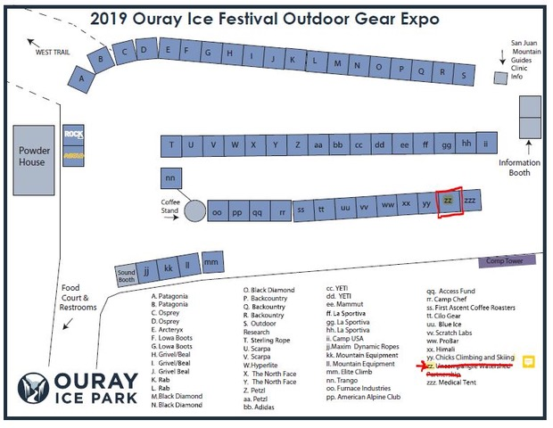

Dark Skies – Val Szwarc

The documentary film “Saving the Dark” will be shown at the Sherbino on April 5. The Black Canyon Astrophotography Society will show some of their photos at this ROCC Talk.

The committee is still working with the Town of Ridgway to update their lighting code. And Jen Coates will be discussing this update with her staff in February.

Norwood has just recently updated their lighting code.

WCA – Al Lowende

WCA will finalize its Platform at the Board meeting next week.

WCA has had good success working on oil and gas issues, such as the methane rule, and
the youth voter initiative.

The board will be working on getting a IRC 501(4) organization up and running, which can be the political arm of WCA, and will be named Rural Colorado Voters.

Al is now the longest serving board member at WCA and would like someone else to volunteer to take his position as the board’s ROCC representative. Al would rather be a board member-at-large.

ROCC Talks – Kate Kellogg

See report below.

Grants – Scott Williams for Dave Jones

What was left in The Chris Pike Memorial Fund has been distributed to Ridgway Cares and the Ridgway Food Pantry.

Membership – Austin Ray

ROCC has 81 memberships which represent 134 individuals. ROCC so far this year has received $2,896 in dues.

The committee may hold a membership recruitment house party this summer.

New Business

Parking Lot Sale will be on Saturday, May 18th at a place yet to be determined. Most likely the location will be either the 4-H Events Center or the town’s lot behind the library.

Kate Kellogg said she will contact Jane Haefner to see if she would like to be the coordinator for the sale.

There was quite a bit of discussion on whether or not ROCC should continue hosting the Parking Lot Sale. The consensus was that ROCC should partner with another group this year to run the sale, and let that group take over running the sale next year.

Kate Kellogg, Don Swartz and Lisa Thomason will work on the sale this year.

Adjourn

Jim Stephenson made a motion to adjourn and Carolyn Ray seconded the motion. The motion passed.

