ROCC General Meeting Draft Minutes
Thursday, June 15, 2017
Ridgway Community Center

Kate Kellogg, Vice President, brought the meeting to order at 7:10 pm.

1. Announcements - Kate Kellogg
a. Brad Wallis, Treasurer of Top of the Pines, Inc., has indicated that the TOP Board of Directors is looking for three volunteers to join TOP's Board of Directors. Any one interested in joining the TOP Board should contact Brad at: grandcanyonwally@yahoo.com.
b. Volunteers are needed for the July Concerts in the Park composting/recycling stations. Volunteers can sign up at: http://signup.com/go/WxMWiNa
c. D3 Indivisible is holding a Don Coram Town Hall meeting on June 21 at 6:30 pm in the 4-H Events Center.
2. Presentation by Pete Dronkers of Earth Works and Jennifer Thurston of INFORM -
Protecting Colorado's Rivers and Streams from Mining Pollution: Supporting Amendments to the Colorado Mined Land Reclamation Act.
As a result of these proposed amendments (1) "Corporate Guarantees" for reclamation bonds would no longer be allowed. Reclamation bonds must front actual money or assets, not good faith promises of financial health down the road and (2) Reclamation bonding requirements would change to reflect the high cost of water treatment during the life of a mine, and bonding authority would change to reflect these specific costs.
These amendments would protect future generations by reducing legacy mining problems in the future.
These amendments will be introduced in the February 2018 legislative session. Representatives McLachlan and Becker will sponsor these amendments.
Right now Earth Works and INFORM are trying to line up groups, organizations, BOCCs, Towns, Cities, and watershed organizations to support these amendments. The Division of Reclamation, Mining and Safety and is supporting these amendments.
If you wish to send a letter to your Representative about supporting these amendments please go to: http:/bit.ly/CO_lege
If you would like a copy of the actual bill that will be introduced next year please contact either: pdronkers@earthworksaction.org (775-815-9936) or jennifer@informcolorado.org (970-859-7456).
see support letter below:
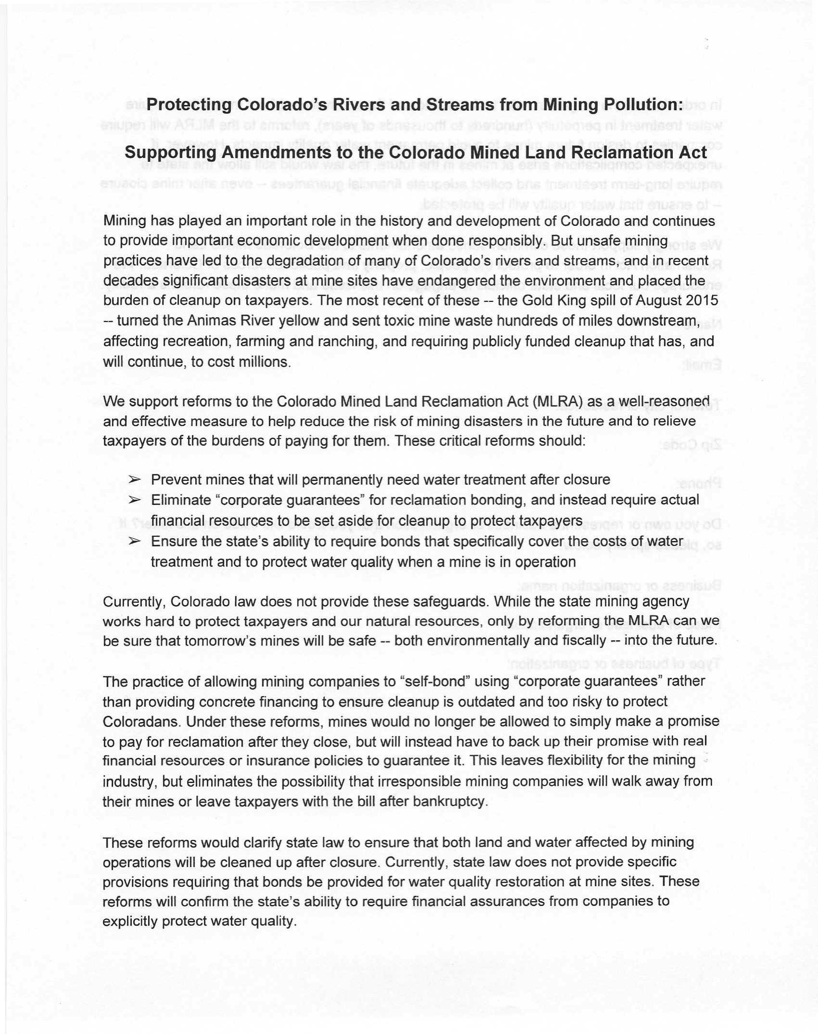

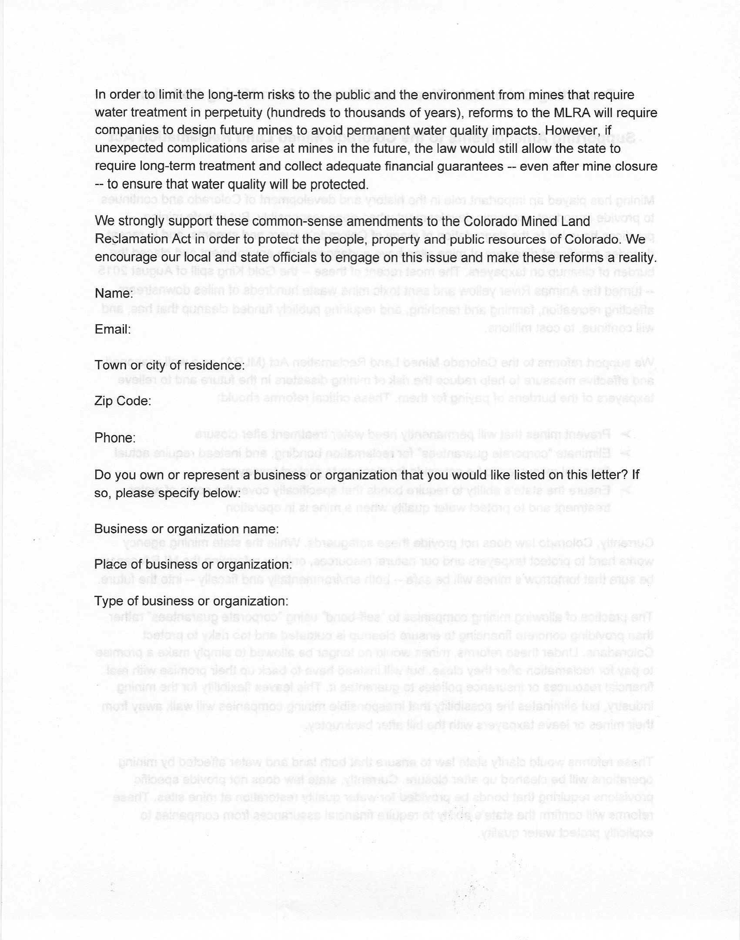

3. Adopt Minutes of March 16 Meeting
Rein Van West made a motion to approve the minutes. Rich Niemeier seconded the motion. Motion passed.
4. Treasurer's Report - Scott Williams
see attached report below on pages 5 and 6.
Scott reported that ROCC has received an anonymous donation of $5,000 with no stipulation on how the money is to be spent. However, Don Swartz and Kate Kellogg will talk to the donors to see if they want the money spent in any particular way.

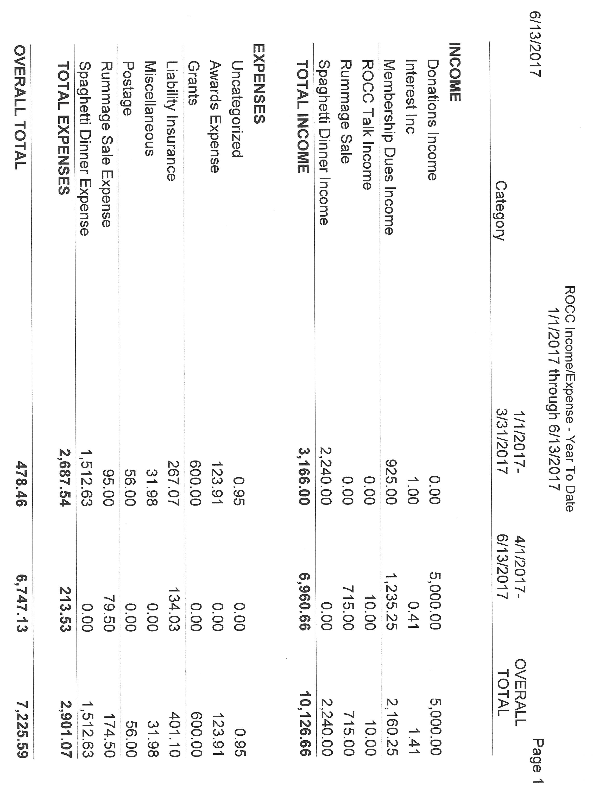

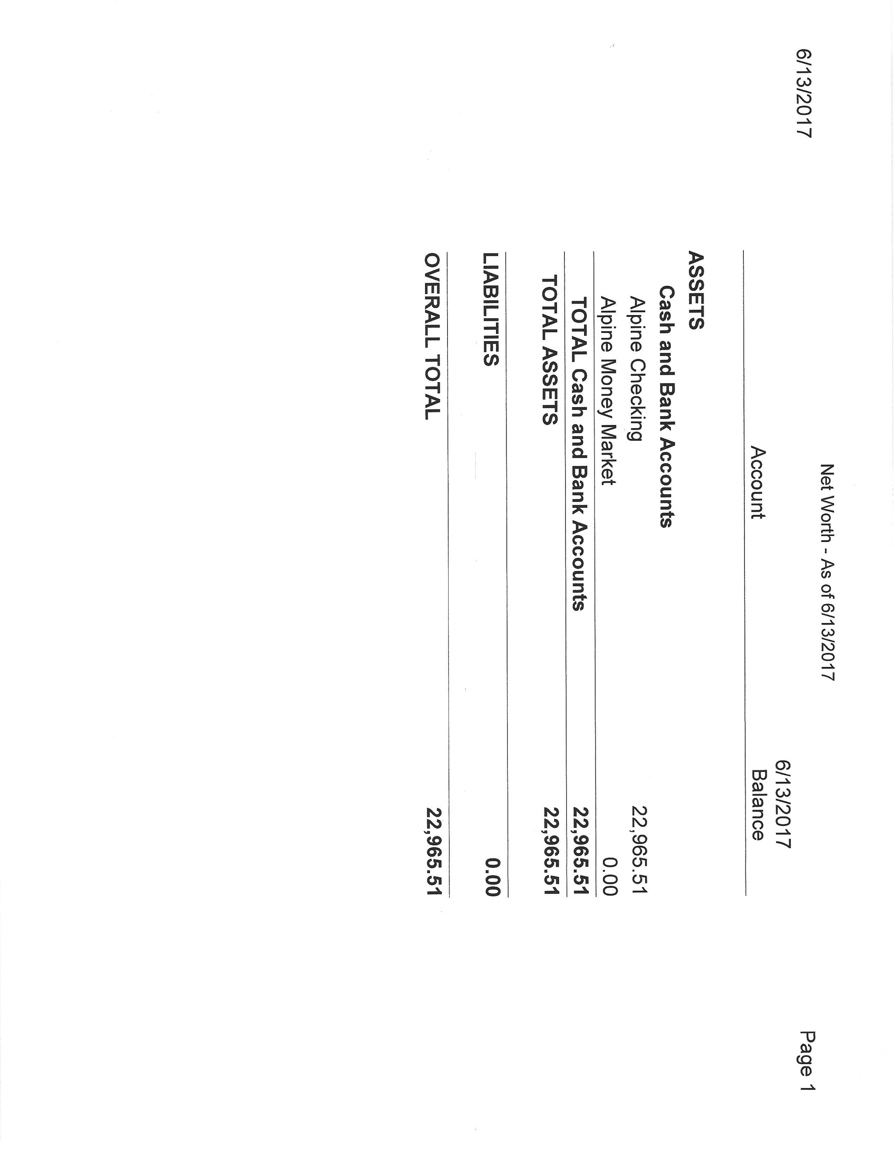

5. Old Business
a. Parking Lot Sale Report - Rich Niemeier
Rich said that there were 52 booths this year versus 62 booths last year, but that the number of attendees seemed to be about the same as last year.
Also this year the vendors were much better about cleaning up their booth areas and not leaving as much garbage to be cleaned up as last year.
Roze Evans designed and had a very nice ROCC public lands banner printed that was hung behind the ROCC table.
Some time in the future ROCC will have to decide if we want to continue the parking lot sale at the 4-H Events Center or move it back into the vacant lot north of the Ridgway Library.
6. Committee Reports
a. Grants Committee - Dave Jones
see Grant Scoring Sheet and report below on pages 8 and 9.
Dave passed around a sheet for recycling/composting volunteers for the July Concerts in the Parks.
Dave also mentioned that 450 people have signed a petition to the SMPA Board to encourage Tri-State to increase renewable energy production from 5 percent to 10 percent of their total energy production. Wendy Fenner passed around a petition sign up sheet.
A motion was made by Scott Williams to ratify that the grant committee has the authority to spend up to $500 on grants without a vote of the ROCC membership. Roze Evans seconded the motion. Motion passed.
The Ridgway Community Garden is asking the Grants Committee for $1,000 for the new one acre community garden being planned in the Green Street Park just south of the high school.
Don Swartz and Kate Kellogg will ask the anonymous donors if some of their $5,000 donation can be use for a grant to the Ridgway Community Garden.
This donation request will be taken up again at the August ROCC Business Meeting.
Chris Lance mentioned that the garden applied for a $350,000 GOCO grant, but the grant was denied. So the garden will be reapplying for a GOCO grant, but they need 10 percent of the grant request ($35,000) to be matching funds. And these matching funds are needed by September 1. That is why the garden is asking for a grant from ROCC.
Project title:____________________________________________ Date:___________
ROCC endeavors to build, nourish and protect a healthy spirit of community dedicated to a broad range of quality of life issues and projects in Ouray County. Please rank the ROCC Grants proposal on the following criteria, and then add the points to determine the total score. Award 0, 1 or 2 points based on whether the proposal doesn’t meet, partially meets, or completely meets the goal. Next, explain whether you agree with the score and the reasons you are in favor or opposed to approving the application.
____________
____________
____________
____________
____________
____________
____________
Score (0-2)

- Organize and enhance the flow of information within the group and the greater community.
- Promote sustainable environmental practices within the region.
- Promote socially responsible and economically practical land use policy while maintaining respect for citizens' property rights.
- Initiate and/or support projects within the community, which add missing elements to the quality of life in the region.
- Promote and maintain social, economic, cultural and educational diversity and thus stability within the community
- Communicate ROCC goals and project support to the community
Total Score
Your Conclusion (circle or “X”):
Strong support Weak support Neutral Weak opposition Strong opposition
Your Rationale:
______________________________________________________________________________
________________________________________________________________________________________________________________________________________________________________________________________________________________________________________________________________________________________________________________________
Your Name:

At a Grants Committee meeting we had a couple of weeks ago, it was proposed that all ROCC Officers/Board Members (along with other ROCC volunteer members) be part of the Grants Committee. This committee rarely meets and most meetings are done via email. If you received this, you are now a voting Grants Committee member (unless you object). Al & Roze, Donna & Bob, you each, individually get your own vote.... There was additional discussion about how to improve our processes. We decided to add a question to the application to clarify if and how ROCC would be recognized for the grant. I also proposed a more formal evaluation process with scoring based on our ROCC mission statement. (We used the first part of the mission in the background and not as an award criterion as the participants felt it was overly broad.) I have set up a ROCC Grants Committee Google Drive, you are now members, and that drive has both the latest application and proposed scoring sheet. Please let me know if you have trouble accessing these, give feedback and propose edits! Also, we have two current applications needing evaluation, one from Ouray Beautification and the other from the Community Garden. Those are in the Grants Applications folder. The five Grants committee members who met agreed that the Ouray B application was weak but suggested $400 if ROCC would be suitably recognized. (A key consideration was that we have not been doing much in Ouray....) More on that potential recognition from Kate. Please try to apply the new/proposed evaluation form to these new applications as a way of evaluating both the requests and the tool. Note: the garden grant application is larger than usual ($1000) but is for next year and is only an IOU - to be awarded if they get the GOCO grant.
Thanks for your help!
Dave
P.S. Our committee has a budget of $1500 this year. We have spent $500 thus far, supporting the UWP RiverFest.

b. Clean Energy Committee - Rein Van West
see report below.
Rein mentioned that the Norwood 200 kilowatt solar system is 50 percent sold out.
Wendy mentioned that since the LED lighting was put into the two Ridgway schools the number of behavioral problems with students has decreased quite a bit.
The next committee meeting is Thursday, August 10th.

ROCC CLEAN ENERGY COMMITTEE (CEC) JUNE 15, 2017
Talking Points:
- SMPA Updates and Annual Meeting Take-A-Ways
- Updates:
- School Energy Audit by CEO Energy Savings for Schools
- Solar Permit Costs Reviewed by BOCC (Jill Markey – APE)
-OLD: permit reviewed in Building Office by as many as 6 people; NOW: permit reviewed in Land Use Office by Brian Sampson that cuts down turnaround time;
-OLD: $350 for a solar permit up to $500 ($350 would be refunded after installation); NOW: $50 for a standard review permit
2 % sales tax refund is not happening any longer (on a 3 Kw system priced at $15K that would be $300). A 3 Kw system is the largest reimbursed by SMPA at $0.75/watt: 3,000 x 0.75 is a $2250 rebate.
Plan review refund is gone, too.
- Electric Vehicle Charging Station
- Commercial – PACE
- EcoAction Partner Programs: Green Lights/Green Business Certification/County Energy Use
- State Energy Legislation – Colorado Energy Office at crossroads

c. ROCC Talks Committee - Kate Kellogg

Scott Braden of Conservation Colorado will speak on Public Lands on Wednesday, July 19.

d. Social Justice Committee - Vicki Warner Huggins

see report below

Robyn Cascade reported that there will be a Rapid Response Team webinar on June 18th.

Social Justice Committee Report
June 2017
The committee has continued its efforts regarding affordable housing and Immigrant Rights. Members attend Town Council, BOCC, planning commission, and OCHA meetings. Members have met with community leaders, elected officials, and stakeholders regarding both issues. Goal for this fall regarding affordable housing is to host another affordable housing forum/summit. Committee members created a draft for possible changes to Ridgway’s mission statement regarding diversity and inclusiveness and presented it at Town Council Meeting. Town Council accepted these revisions at the last meeting. Town Council has also agreed to co-sponsor a banner with ROCC with mutually agreed upon language regarding this same message. The committee would like to request that ROCC support this banner with contribution of $126.
The Social Justice Committee has also been approached to identify needs regarding availability of victim’s advocacy for Ouray County residents. The committee will look at this issue at the next meeting to determine what actions will be taken.
Next meeting - June 26, 5 pm at Church of the San Juans, Ridgway, CO

e. WCC Legislative Action Committee - Roze Evans

see report below

2017 WCC Legislative Committee Activities Summary
- Met weekly - Tuesday at 12:00 via telephone
- Lobby trip with more participants than ever
- Two additional trips with testimony around bills
- LTEs written on various topics
- Action Alerts sent out every other week
- Utilized Legislative Action Team several times to address specific issues

2017 Bill Summary

SB17-105
Consumer Right To Know Electric Utility Charges - passed signed by governor

SB17-089
Allow Electric Utility Customers Install Energy Storage Equipment
Concerning the rights of consumers of electricity to install electricity storage systems on their property. - Failed to pass out of the Senate

HB17-1021
Wage Theft Transparency Act
Concerning the release of information by the division of labor standards and statistics in the department of labor and employment concerning an employer's violation of wage laws. - passed and signed by governor

HB17-1152
Federal Mineral Lease District Investment Authority
Concerning the authority of a federal mineral lease district to manage a portion of the direct distribution of money from the local government mineral impact fund to counties for the benefit of impacted areas. - Governor signed

SB17-022
Rural Economic Advancement Of Colorado Towns
Concerning the coordination of economic assistance for rural communities experiencing certain significant economic events that have led to substantial job loss in those communities, and, in connection therewith, authorizing the department of local affairs to coordinate non-monetary assistance and award grant money to assist rural communities with job creation or retention. Failed to pass out of Senate

SB17-073
Promote Runyon-Fountain Lakes State Wildlife Area
Concerning promotion of the Runyon-Fountain lakes state wildlife area. - Governor signed.

SB17-081
Rural Broadband Deployment
Concerning the use of high cost support mechanism funds for rural broadband deployment. - Failed to pass out of the Senate

SB17-109
Industrial Hemp Animal Feed
Concerning the use of industrial hemp in products designed for consumption. -

Governor signed.

SB17-117
Recognize Industrial Hemp Agricultural Product For Agricultural Water Right Concerning confirmation that industrial hemp is a recognized agricultural product for which a person with a water right decreed for agricultural use may use the water subject to the water right for industrial hemp cultivation. Governor signed.

SB17-145
Electric Utility Distribution Grid Resource Acquisition Plan
Concerning modifications to the electric utility resource acquisition process, and, in connection therewith, promoting a more resilient, reliable, and cost-effective electrical grid through enhanced planning and data transparency. - Failed to pass out of Senate.

HB17-1174
Exempt Rural Telecommunications Local Improvement District Requirements Concerning the establishment of an exception for rural counties from the requirement that a county must first contract with a telecommunications service provider before establishing a local improvement district to fund the construction of a telecommunications service improvement. - Governor signed.

HB1256 - Oil and Gas Facilities Distance from schools - Failed in the Senate

COLORADO ENERGY OFFICE
The state entity that is required to look at renewable energy is gone. C-PACE will not be affected. - Not to have a state entity that is required to look at renewable energy is a huge loss for Colorado. C-PACE will not be affected. 24 FTEs will be eliminated on July 1.

Compressed natural gas and weatherization programs will probably not be affected because of federal matching funds.

f. Western Colorado Congress Report - Al Lowande

The WCC annual conference will be held on Saturday, August 26th in Grand Junction.

g. ROCC Membership Committee - Roze Evans

WCC is not very good when it comes to keeping track of membership.

WCC should separate donations from membership and not count a donation as a membership unless the donation specifies that it is for membership.

h. WCC Public Lands - Robyn Cascade

a) There are 27 national monuments whose status is being reviewed. If you wish to comment on these monuments please use the link in Information Hub of WHAT ROCCS? on the ROCC website.
b) The Grand Mesa, Uncompahgre and Gunnison (GMUG) Forest Plan Revision process has begun the assessment phase. The Wilderness Society and High Country Conservation Advocates are taking the lead on this with support from WCC and other conservation coalition members. ROCC members are encouraged to engage in the process.
c) We are hoping that Senator Bennett will reintroduce the San Juan Wilderness bill.

7. New Business

Spaghetti Dinner Committee - Chris Pike

This report was postponed until the August ROCC Business Meeting due to this meeting running later than expected.

Scott Williams made a motion to adjourn the meeting. Roze Evans seconded the motion. Motion passed and the meeting was adjourned at 9:25 pm.

