ROCC Business Meeting Minutes
05-15-14

1. Guest Speakers – Kevin Studley and Russell Evans from Transition Lab in Montrose
Kevin is a student at the Transition Lab and Russell is the Director of the Transition Lab. Students are taught viable, accessible and replicable sustainability. Students are taught small-scale solutions designed to address the biggest challenges of our time. Since 2010, the lab has experimented with small-scale models that create employment, affordable housing, local food production, community engagement, and leadership development.
Transition Lab was the winner of MIT’s Climate CoLab “Local Solution” contest. Out of 40 entries worldwide it’s model won both the judges and popular choice award for being the most viable, replicable, and effective idea for reducing CO2 emissions and creating a more sustainable future. The Lab’s curriculum includes local food production, knowledge of oneself, community engagement, low cost infrastructure, entrepreneurship, creating small business models, waste as a resource, and many other topics.
Classrooms include farms, gardens, metal fabrication workshops, coffee shops, and other venues. The Lab hopes to foster economic freedom and the reduction of carbon usage among young people. Students often live in the homes of a local families rental free in exchange for their working 10 hours per work at the home.
2. Announcements
a. Adopt-a-Highway Cleanup Report – Tom McKenney
The cleanup took place on Saturday, April 19 from mile markers 105 to 107 on Hwy 550 and the cleanup was over by Noon. Tom wanted to thank Austin Ray, Dave Jones, Judy Chamberlin, Dudley Case, Howard Green, Steve Slade, Randy and Jen Parker, Scott and Sheelagh Williams, and Rick Weaver for participating in the cleanup.
b. Cottonwood Creek Cleanup Report – Nick Williams
The cleanup took place on Saturday, March 29th from 10am to 3pm. The Town of Ridgway provided equipment and gloves. A lot of trash was removed from the creek including part of an old car. Nick thanked all the participants of the cleanup for doing such a good job.
c. Membership Party Report – JoAnne Williams
On May 7th a very successful membership recruitment party was held at Howard Greene and Chris Lance’s house. There were about 20 potential new members who attended the party and several have already joined as new members of ROCC. A number of leaders and members from both ROCC and WCC made presentations to the attendees.
d. Parking Lot Sale Update – Eve Becker-Doyle
Eve thanked the many great volunteers who have taken it upon themselves to promote and produce the parking lot sale, which will be held on Saturday morning, May 17th in Ridgway. Don Rogers is seeking donations for the ROCC sales booth. These donations can be dropped off at Don’s house. Sharon Case volunteered to work the north entrance with Roze Evans.
e. Spaghetti Dinner Speaker for 2015 – Suggestions needed – Jen Parker
We may need to pay a speaker for next year. If anyone has a suggestion for a speaker please contact Jen Parker or Roze Evans. Dayton Duncan was suggested as a speaker. He could speak on the history of the last frontier.
3. Treasurer’s Report
Scott is out of town so there was no report.
4. Old Business
a. Treasury Reserve – suggested board guidelines – Jen Parker
The ROCC Board of Directors recommended that a $10,000 reserve be maintained in ROCC’s Treasury and that the remainding amount in the Treasury could be used by the Grants Committee.It was pointed out that ROCC is doing well financially but that WCC is not doing well financially and that ROCC should consider renegotiating its membership fee split with WCC.
Howard Greene made a motion, which was seconded by John Hollrah. Motion: ROCC should set aside a $10,000 reserve in its Treasury to be used only when extraordinary circumstances arise.After a few minutes of discussion this motion was approved by a majority of the ROCC members present.
b. Social Justice and Membership Diversity Ideas – Al Lowande
Al pointed out that there are not enough young people in WCC and its five local organizations. He asked whether WCC, including its member organizations, is just an environmental organization or a broader issue oriented organization, which includes social justice issues. It was suggested that ROCC might want to set up a social justice committee.
Al made a motion, which was seconded by Chris Pike. Motion: ROCC should inform WCC that ROCC is in favor of WCC pursuing social justice issues as far as WCC can feasibly do this. After a discussion, the motion was approved by a majority of the ROCC members present.
Roze Evans then presented GRID Alternatives’ Solar Affordable Housing Program. This program makes solar power accessible to families who need the savings most while providing hands-on solar installation experience to volunteers and job trainees. See gridalternatives.org/Colorado.

The Solar Affordable Housing Program is GRID Alternatives' core program. We provide low-to-no cost solar electric systems to families that qualify as low income, and install them using a barn-raising model that gives volunteers and job trainees hands-on experience they can use to get jobs in the growing solar industry. Each project has a triple impact: energy cost savings that help struggling families put food on the table or pay medical expenses; a classroom in the field for solar aspirants that supports local employment and the growing solar industry; and a reduction in greenhouse gas emissions that helps local governments reach their emissions targets and contributes to cleaner air for everyone.

c. WCC Local Foods Committee – Robyn Cascade
The committee needs volunteers to write letters-to- editor, a ROCC liaison, telephone callers, etc. The committee is working on an expansion of the Cottage Food Act, which Gail Schwartz from WCC helped draft. This act will help low income families since they can now sell food they cook in their home kitchens. Robyn noted that a pH of 4.6 is the important number for food prepared in a home kitchen.
d. Air and Water Committee
The committee needs a chair and volunteers
e. ROCC website demo – Dave Jones
Dave decided to postpone this presentation because the meeting was running late.
5. Committee Reports
a. Public Lands – Jim Stephenson
Jim said they are still working on trying to get Rep. Tipton to actively support the San Juan Wilderness Bill. The WCC and ROCC Public Lands Committees and the WCC Uranium Committee met with the BLM’s Uncompahgre Field Office Director, Barb Sharrow, to talk about their Regional Management Plan. However she could not speak directly about this plan at this meeting since the plan has not been released to the public yet. See attached map of the Regional Management Plan area on the next page.
WCC is holding trail hikes on June 7th in the Dry Creek area near Dominguez and on June 17 near Jumbo Mountain in the North Fork area. If you want more information talk to Jim.
b. WCC Uranium Committee – Dudley Case
1. U.S. Dept. of Energy’s Uranium Leasing Programmatic Environmental Impact Statement. The PEIS covers 26,000 acres of mining in San Miguel, Montrose, and Mesa Counties. The final PEIS is basically the same as the draft PEIS. the PEIS has 5 alternative plans of action. DOE supports Alternative 4, which continues the uranium-leasing program on 31 tracts for the next 10 years or another reasonable period. This alternative will allow another 19 possible new uranium mines.
Alternatives 1 and 2 would be better since those alternatives turn back these tracts to the BLM without any mining being allowed. At the UFO-RMP meeting with Barb Sharrow, mentioned previously, she stated that the BLM has cleaned up all but 2 or 3 uranium mines on BLM land and most of the remaining uranium mines are located on private land over which the BLM has no control. So other agencies of the Federal Government or the State of Colorado would have to oversee clean up of these mines. There is a good article in The Watch’ May 15 newspaper thisweek about PEIS.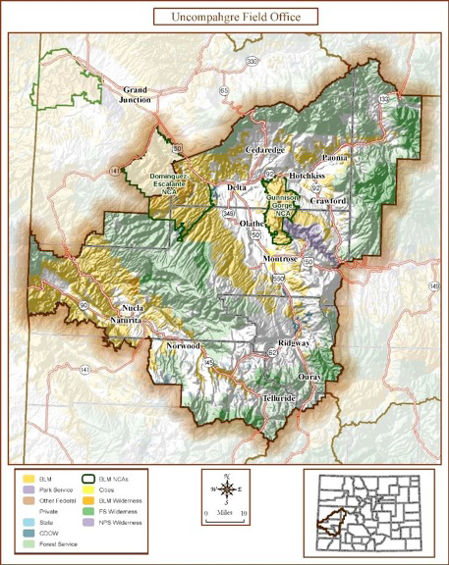

2. Colorado Senate Bill 192 – Uranium Processing Groundwater Protection Act.
This bill has been passed by the Colorado Legislature and is going to Governor Hicklooper to be signed. This legislation requires uranium operators to actively clean up contaminated groundwater to the same quality level it had been before milling. It also increases spill-reporting requirements and increases the public’s role in how uranium mills are licensed. However, the bill was amended to remove a section that would have protected Colorado from future experimental uranium procurement technologies such as ablation (often called fracking for uranium). Emily Hornback has written a good article on this bill in the WCC’s Summer 2014 Clarion newsletter.
c. Transition OurWay Energy Committee
Brad Zaporski, SMPA’s Manager of Energy, Member Services and Marketing spoke to the committee on May 6. Telluride has purchased about 450 solar panels (10 percent of the array) from SMPA for use by lower income residents. With that purchase about 50 to 60 percent of the total Paradox Solar array has been sold. Each panel produces about 225 watts. Right now the Paradox array is producing about 25 percent more power than SMPA’s business model predicted, in part because of the clear blue skies and high altitude of Paradox Valley. Also, snow is not a big problem there because of the dryness of the valley. Net metering pays a little bit more back to customers than the solar panels purchased in the Paradox array, but customer don’t have to worry about maintenance of their solar panels when they buy into the array. Currently SMPA has the highest net metering penetration in the state of any power company, approximately 1.04 percent of SMPA’s total electrical meters. According to Tri-State (SMPA’s parent corporation) SMPA has reached its 5 percent limit on electrical power generation from renewable energy. However, this 5 percent does not include net metering. Most of the renewable energy SMPA gets is from small hydroelectric plants. Tri-State is currently building a new 70-megawatt wind farm in NE Colorado. But Tri-State still generates about 50 percent of its energy from coal plants. In the future, Brad is predicting that distributive energy generation could become cheaper than centralized energy distribution. The City of Ouray, Mountain Village, and City of Montrose are all currently getting electric charging stations installed, but not the Town of Ridgway. The new 2014 National Climate Assessment Report was released today. This report may be found at: nca2014.globalchange.gov/downloads. You can either download the entire 850 page report or individual sections of the report. The Southwest part of the report is found on pages 462 to 486.

d. WCC Legislative Committee – Roze Evans
Not all these are law just yet, but we expect they will make it through and be signed by the Governor.
-SB192 Uranium Bill
-SB5 Wage Protection
-SB186 Energy Efficiency in Rural Public Buildings
-HB1303 Remote Testimony
-HB1356 Higher Oil & Gas Fines
-SB 13-152 - Renewable Energy Standards for electricity generation in Colorado passed in 2013
•4 bills were introduced to reduce or eliminate Renewable Standards set last year with SB 13-152.
•WCC helped to successfully defend against reducing or q eliminating standards. All 4 bills died quickly with WCC’s help.

Other bills that passed:
HB14-1326 - Tax Incentives for Alternative Fuel Trucks
SB14-009 - A Disclosure of Possible Separate Ownership of the Mineral Estate in the Sale of Real Property
SB14-028 - Expansion of Eligibility for the Receipt of Disbursements from the Electric Vehicle Grant Fund for the Installation of Electric Vehicle Charging Stations

e. Energy Committee Report – Al Lowande

Since the meeting was running late Al postponed this report.

f. Land Use – Don Rogers

The BOCC has scheduled a Land Use Code work session for Tuesday, May 20 at 9am at the Land Use Office on Mall Road. This session will probably not deal with Section 9 – Visual Impact.

The BOCC may have scheduled a Land Use Code – Section 9 – Visual Impact work session for Wednesday, May 28 at 9am at the Land Use Office on Mall Road.

All three members of the BOCC agreed to remove mandatory blending from the draft Section 9 they are working on and place blending back in the point system with more weight than in the current code.

Also, only six roads have been added and none of these roads are in the alpine zone. County Roads 5, 7, 8. 10, 24, and 24A were added to the draft.

g. ROCC Community Support Committee (Grants Committee) – Dave Jones

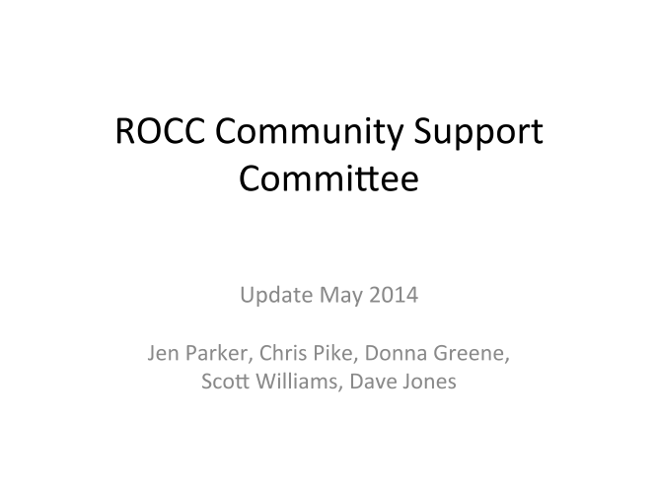

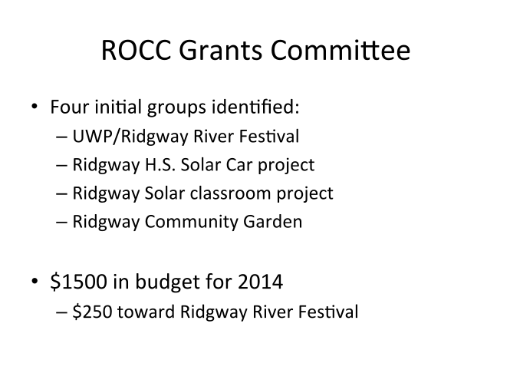

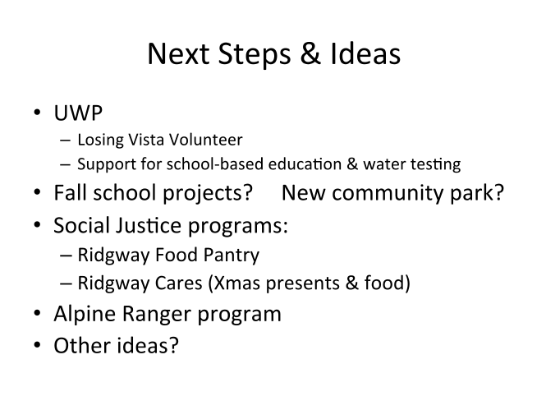

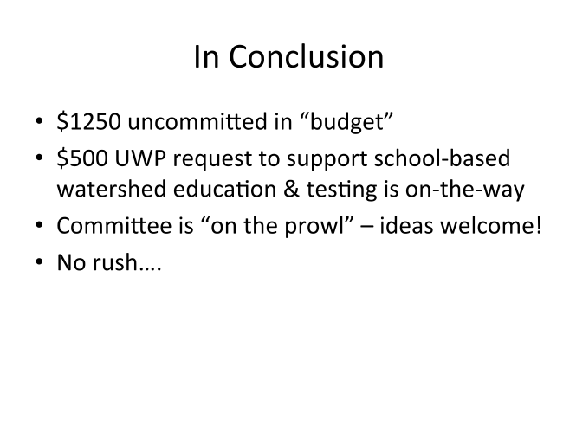
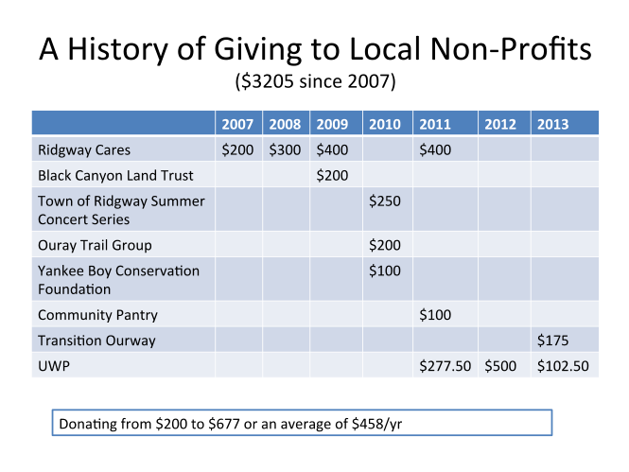

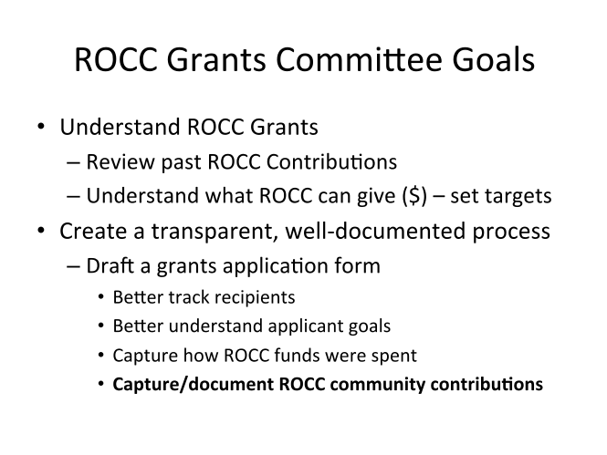
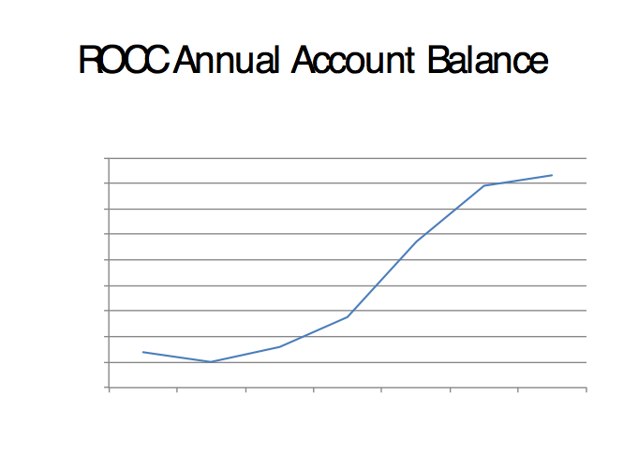
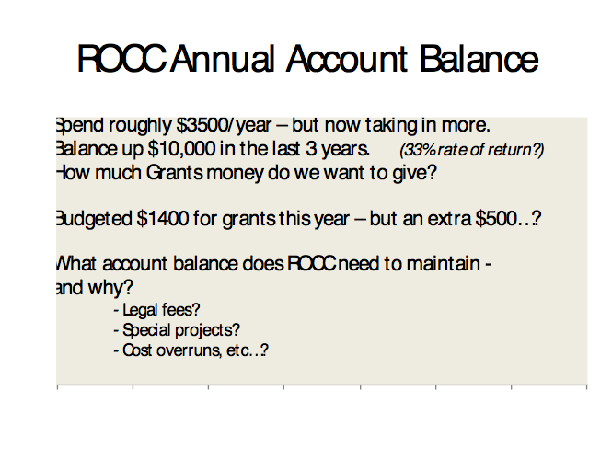
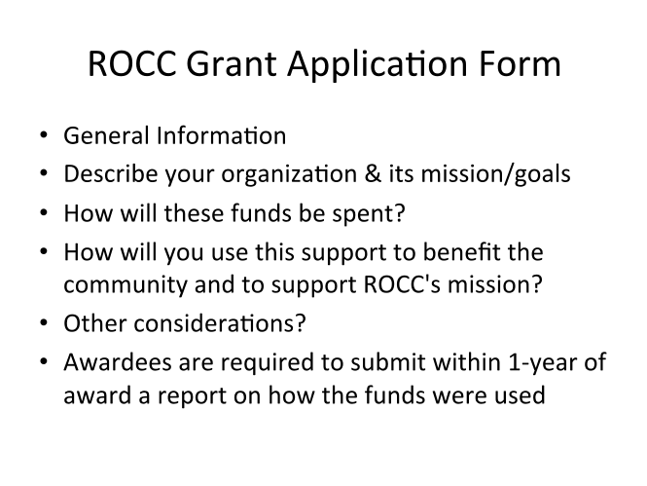

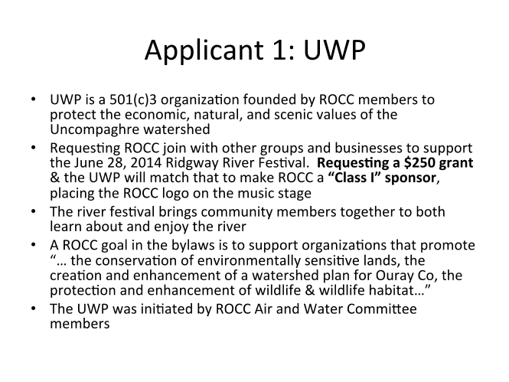

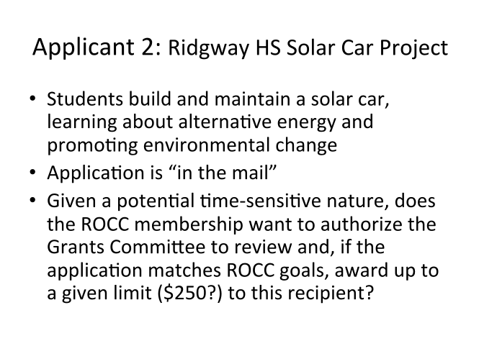
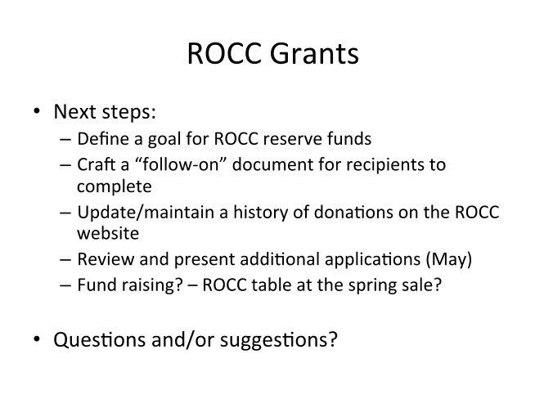
h. ROCC Talks – Roze Evans
June 18 ROCC Talk- Sherbino Theatre

"Cutting-Edge Advances in Water Treatment & Energy Production Using Microbes" This ROCC Talk will deal with sustainable water treatment and energy production using a microbial electrochemical system. Presenter: Casey Forrestal, University of Colorado Boulder

Date: June 18, Wednesday
Time: 7:00 (with treats and conversation at 6:45)
*********************************************

August 21 ROCC Talk - Sherbino Theatre

Film, "Uranium Drive-in", an excellent story showing of both sides of the uranium exploration and mining issues. Sherbino Theater, 7:00pm (with treats and conversation at 6:45 pm)
**********************************************

Oct. 16 -- ROCC Talk, "Re-cycling - Where Do Your recyclables Really go?" Ridgway Town Hall, 7:00 pm (with treats and conversation at 6:45 pm)

6. New Business
a. ROCC Chapter Evaluation for WCC/WORC – Jen Parker
Jen stated that the membership-telephoning group had done this late last year. So there would be no need to do this again.
b. John Fielder Wild 50th Event in Montrose – Jen Parker
WCC and Conservation Colorado are working together to sponsor a series of events entitled “Wilderness 50th Anniversary” on the West Slope with photographer John Fielder. We have one scheduled in Montrose for November 20th and were wondering if ROCC would want to be an official sponsor with UVA, Conservation Colorado and WCC. We don't have all the details of what sponsorship looks like at this point, but will include a bit of $ committed to the event, as well as at least one ROCC point person to join the planning team.

c. Alpine Ranger Issue – Chris Pike

There will be no full time western Alpine Ranger patrolling the high country lands and 4WD roads in Ouray County this year after San Miguel County pulled its funding for the program in part because 10-year-old children are allowed to drive OHVs without driver’s licenses on high country lands and roads. Chris is asking that the ROCC officers/directors look into this issue to see if ROCC can persuade the City of Ouray and Ouray County to change their policies on allowing children to drive OHVs without licenses.

