SAY NO TO DAMS ON MAROON AND CASTLE CREEKS
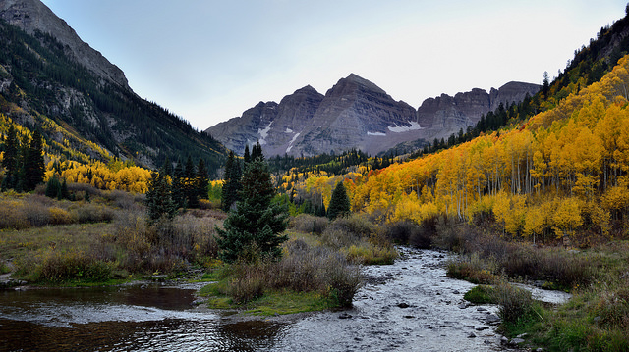
Maroon Bells and Maroon Creek | Photo: Mark Stevens
Two dams backing up lake water into a Wilderness Area, in one of the most scenic spots in Colorado should never even be considered, much less the subject of serious consideration. The Aspen City Council voted to move forward with a resolution to construct two new dams. The first is a 150 foot dam on Maroon Creek and the second is a 175 foot dam on Castle Creek. These dams would flood protected land in the Maroon Bells Wilderness, one of the most visited and photographed valley’s in Colorado. What's worse is that the dams are completely unnecessary for the health and vibrance of Aspen. Aspen does not need these dams for municipal water supply, climate resiliency, or for stream protection. The city's own 2016 water availability report clearly shows that Aspen does not need these dams. There are several cost effective and environmentally sound alternatives that communities throughout the west are pursuing to meet future water demands while building community resilience to climate change.
TAKE ACTION TODAY
The Council will take formal action on October 10th. So please send a letter to Aspen City Council today
The City of Aspen is proposing to put two dams in one of the most scenic spots in our state: Maroon Bells. What's worse is that these dams are not needed.

Will you send a message to the City of Aspen, urging them to stop these destructive projects?
Last month, Aspen City Council voted to move forward with a resolution to develop a 150 foot dam on Maroon Creek and a 175 foot dam on Castle Creek in the shadow of the world renowned Maroon Bells. Constructing a pair of 15-story tall dams and flooding the Castle and Maroon Creek valleys would likely cost hundreds of millions of dollars, but the monetary price would pale in comparison to the damage the dams would do to the natural environment.

Send a letter to the City of Aspen asking them to permanently cancel plans for new dams on Castle and Maroon Creeks.

Aspen's own 2016 water availability report¹ clearly shows that Aspen does not need these dams for municipal water supply, climate resiliency, or for stream protection. These dams would flood private property on Castle Creek and a portion of federally protected land in the Maroon Bells Wilderness.

Dams do incredible damage to rivers. They ruin river habitat, degrade water quality, and cause significant public safety risks. And recent studies show that dams may actuallycontribute to climate change by producing methane from the stagnant water.² The national trend is to remove dams in places like the Maroon Bells, not build them.

The City Council will take formal action on October 10th. So please send a letter to today.

